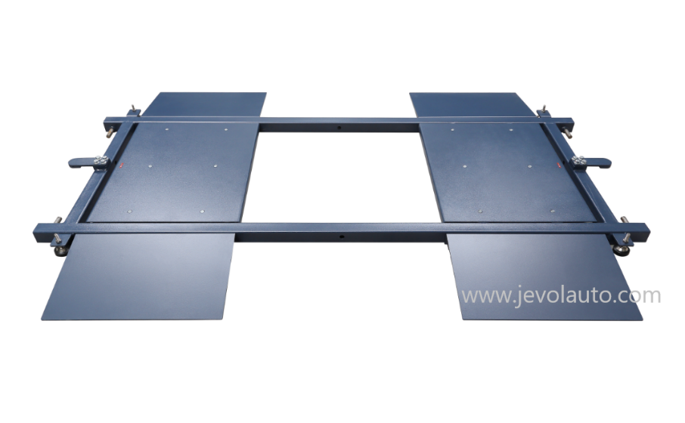
Mobile Sideslip Tester

Technical Parameters:

Items | Parameters
Model | RSS-500M | RSS-700M
Max axle load | 3T | 10T
Test speed | 5-10km/h | 5-10km/h
Range | ±15mm | ±15mm
Testing Plate Length | 500mm | 1000mm

Characteristics
- High precise sideslip tester sensor ensures the accurate reach 0.1mm. Easy to use: only need to drive vehicle through the sideslip tester to check vehicle deviation.
- It can be displayed by Digital Display meter or Computer Control system software.
- Pre-check the vehicle toe-in in case of vehicle need wheel alignment saving your time.
- Check vehicle deviation, toe-in, speed and display on monitor vividly

Option 1 for Console: Digital Display
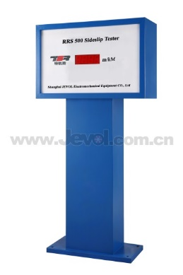

With stable performance to show the testing result directly, print out the result with option micro-printer. The data can also be transferred to PC.

Option 1 for Console: Computer Control System
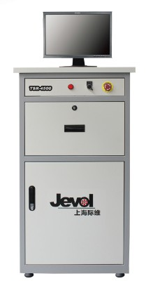
- Embedded industrial computer
- CPU：2.4G
- Memory: 1G
- Hard disk: 160G
- Monitor: LCD 19”
- Industrial computer has high anti-interference and anti-vibration performance. With good heat dissipation performance and long life time.

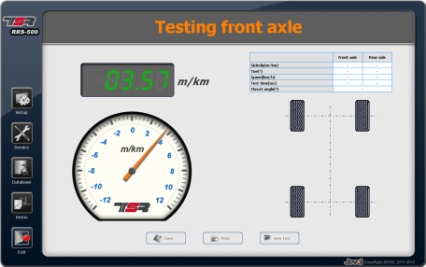
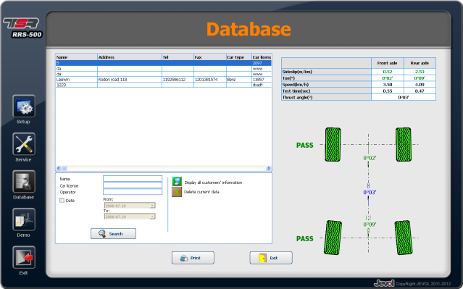
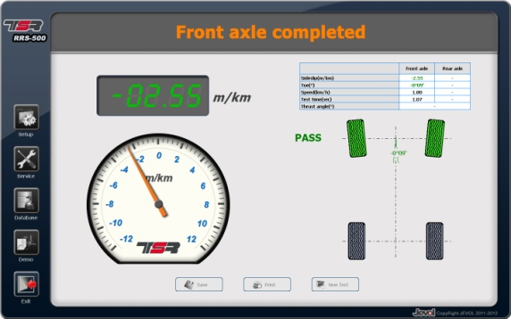
Jevol TSR Software

